THE ARCHAEOLOGY OF THE NORTHAMPTON FURNACE
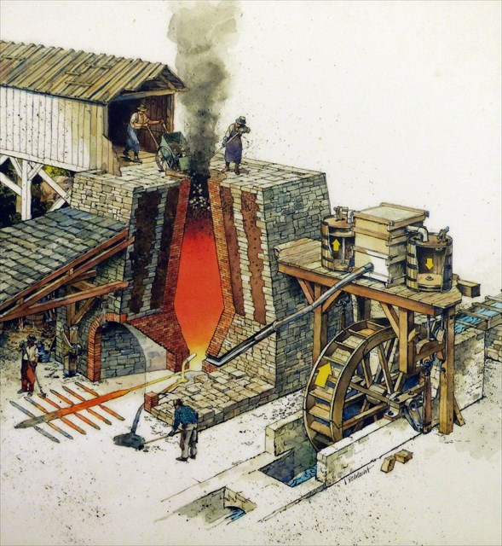
An Archaeological Field School
Summer Session II, 2020
Come and join us uncover the remains of a colonial iron furnace run by the Ridgely Family and help us document the lives of the enslaved and indentured servants who were forced work for the Ridgelys. Students will learn the fundamentals of archaeological field survey and excavation, including site and unit documentation, analysis, and how to present their findings.

Class Details
University of Maryland, ANTH 496: Archaeological Field Methods (6 credits)
Location: Towson, Maryland
Time: Mondays- Fridays from 8:00am -5:00pm
Course Dates: July 13- August 21, 2020

Please contact Adam Fracchia (fracchia@umd.edu) for more information.
**No prior field experience required**

